Joseph Galloway’s Speech to the Continental Congress, September 28, 1774

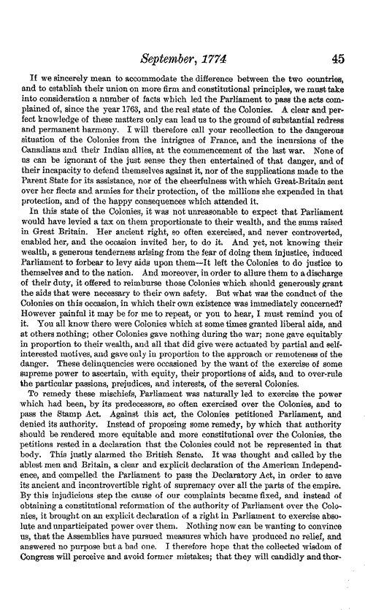
Joseph Galloway served as a delegate from Pennsylvania in the First Continental Congress in 1774. By 1776, Galloway had become a Tory (Loyalist) and then left the colonies for England. In this speech to the Continental Congress, Galloway argues against the rebel cause.
